What is big data?

DATA:
The numbers, characters, or symbols on which a device conducts operations that can be processed and distributed in the form of electrical signals, and recorded on magnetic, optical, or mechanical storage devices.
Big data is also data but it has an enormous size. Big Data is a term used to describe a collection of data which is small in scale which expands exponentially over time. In short, this data is so large and complex that none of the conventional data management systems can efficiently store or process it.
BELOW ARE SOME EXAMPLES OF BIG DATA SYSTEMS:
The New York Stock Exchange generates about one terabyte of new trade data per day
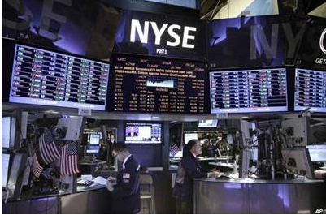
Social Media

The statistic shows that 500 terabytes of new data get ingested into the databases of social media site Facebook, every day. This data is mainly generated in terms of photo and video uploads, message exchanges, putting comments etc.


Types of Big Data
Big Data's could be found in three forms:

- Structured
- Unstructured
- Semi-structured

Structured
Every data that can be stored, viewed, and interpreted in set format is considered' structured' data. Over time, computer science expertise has been more active in creating methods for dealing with and deriving interest from such data (where the format is well defined in advance).
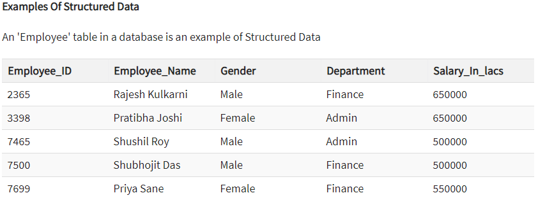

Unstructured:
Any data with a shape or function unknown is labelled as unstructured data. As well as the scale being immense, un-structured data faces multiple challenges in terms of its retrieval to extract meaning from it. A typical example of unstructured data is a heterogeneous source of data which contains a mixture of simple text files, photographs, videos etc.

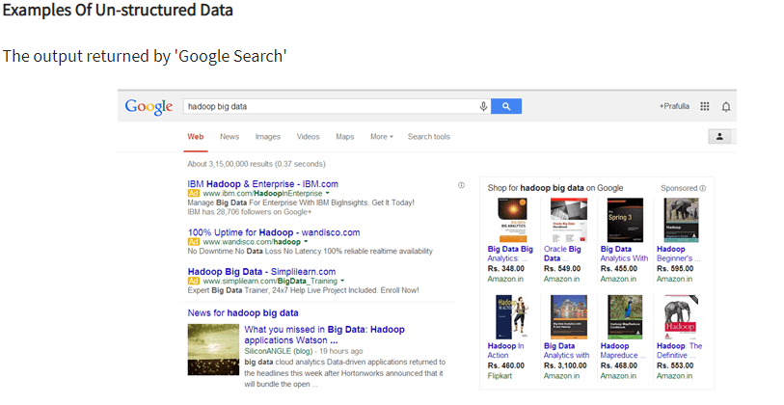 Semi-structured
Semi-structured data may contain data in both ways. We can see semi-structured data as structured in form but it is not specifically defined in relational DBMS with e.g. a table description. Semi-structured data is an example of data contained in an XML format
